

Analysis of the Human Development Index (HDI)

A Data-Driven Exploration of Global and Regional Development Patterns

Course : Concept and Technology of AI (5CS037)
Assignment: Assignment (I)
Student Name : Sagar shah
University Number : 2548866
Submission date : January 10, 2026
Contents
Introduction 1
Problem 1A: Single-Year HDI Exploration (2022) 2
2.1 Methodology 2
2.3 HDI Classification 2
3. Problem 1B: HDI Trend Analysis (2020–2022) 4
3.1 Methodology 4
4. Problem 2: Advanced HDI Exploration 6
4.2 Outlier and Correlation Analysis 7
5. Problem 3: Comparative Regional Analysis 8
5.1 South Asia vs Middle East 8
6. Conclusion 22

Introduction
The Human Development Index (HDI) is a composite statistical measure developed by the United Nations Development Program (UNDP) to assess and compare the level of human development across countries. Unlike purely economic indicators, HDI incorporates three fundamental dimensions of development: health, education, and standard of living.

This assignment focuses on performing statistical interpretation and exploratory data analysis (EDA) using the Human Development Index dataset spanning multiple years and regions. The analysis is carried out using Python and its data science libraries such as Pandas, NumPy, Matplotlib, and Seaborn.

The main objectives of this analysis are:
- To explore HDI values for the most recent year available
- To analyze HDI trends over recent years
- To perform advanced analysis focusing on South Asian countries
- To compare development patterns between South Asia and the Middle East

All analysis steps, data cleaning procedures, visualizations, and interpretations are documented in this Jupyter Notebook as required by the assignment guidelines.

Problem 1A: Single-Year HDI Exploration (2022)

2.1 Methodology
The dataset was filtered to include only observations from the year 2022. Initial exploratory analysis was performed to understand the dataset structure, including the number of observations, variables, and data types.
Data cleaning steps included:
- Checking for missing values and special characters representing missing data
- Removing duplicate records
- Converting numeric columns stored as text into appropriate numeric formats
These steps ensured that the dataset was suitable for statistical analysis.

2.3 HDI Classification
Countries were classified into four official HDI categories based on UNDP thresholds:
- Low Human Development
- Medium Human Development
- High Human Development
- Very High Human Development
This classification helped in understanding the global distribution of development levels.

3. Problem 1B: HDI Trend Analysis (2020–2022)

3.1 Methodology
The dataset was filtered to include the years 2020, 2021, and 2022. Data cleaning ensured consistency across years and countries. Line plots, bar charts, box plots, and scatter plots were used to visualize trends and relationships. 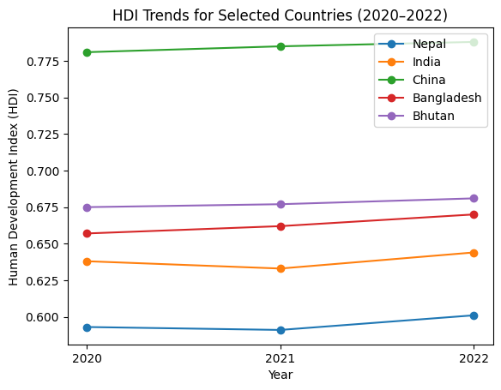

China consistently records the highest HDI and shows steady improvement over the period. Bhutan and Bangladesh demonstrate gradual increases, indicating moderate development progress. Nepal and India experience a slight decline in 2021, likely due to the impact of the COVID-19 pandemic, followed by recovery in 2022. Overall, the figure highlights differing development levels and post-pandemic recovery patterns among the selected countries.
The dataset includes pre-aggregated regional HDI values such as South Asia, Europe and Central Asia, and Sub-Saharan Africa. These entries were used directly to analyse and compare average HDI across regions for the years 2020 to 2022. This approach avoids manual region mapping and ensures consistency with the original dataset structure.

4. Problem 2: Advanced HDI Exploration

4.1 South Asia Analysis
A subset of South Asian countries was extracted for focused analysis. A composite development score was created using life expectancy and GNI per capita indicators.
Countries were ranked based on this composite score and compared with their HDI rankings.
zzzz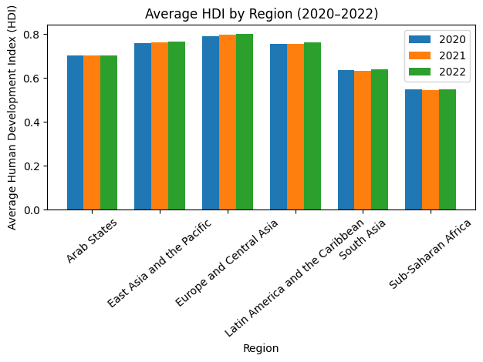
Figure X presents the average Human Development Index (HDI) by region for the years 2020, 2021, and 2022. Europe and Central Asia consistently records the highest average HDI across all three years, followed by East Asia and the Pacific. The Arab States and Latin America and the Caribbean fall in the mid-range, while South Asia and Sub-Saharan Africa show comparatively lower average HDI values.
Across most regions, a slight improvement or stability in HDI is observed from 2020 to 2022, indicating gradual recovery after the disruptions caused by the COVID-19 pandemic. South Asia and Sub-Saharan Africa remain the lowest-performing regions, highlighting persistent development challenges related to health, education, and income. Overall, the figure emphasizes clear regional disparities in human development and differences in the pace of post-pandemic recovery.

4.2 Outlier and Correlation Analysis
Outliers were detected using the interquartile range (IQR) method. Correlation analysis revealed the strength of relationships between HDI and selected development metrics.
Countries with high income but comparatively lower HDI were highlighted through gap analysis.

5. Problem 3: Comparative Regional Analysis

5.1 South Asia vs Middle East
Descriptive statistics were computed for both regions. The Middle East generally showed higher average HDI values, while South Asia exhibited greater variability.
Grouped bar charts and scatter plots were used to compare development indicators across regions.
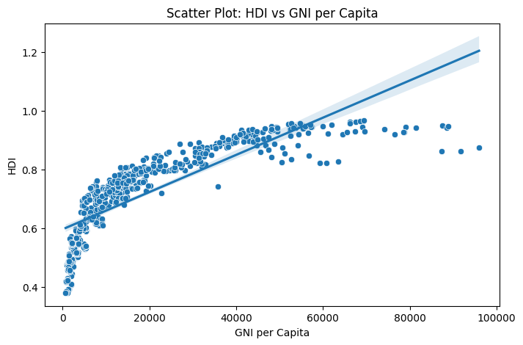
- The scatter plot shows a strong positive relationship between GNI per Capita and HDI.
As income per person increases, human development generally improves.
- At low GNI per Capita levels, HDI increases rapidly with small income gains.
This suggests that basic income growth strongly improves health, education, and living standards in poorer countries.
- At higher GNI per Capita levels, the relationship flattens.
Countries with very high income show smaller gains in HDI, indicating diminishing returns — once basic development needs are met, additional income has less impact on HDI.
- The regression (trend) line summarizes this overall upward pattern, confirming a positive association, even though the data points are not perfectly aligned.
- A few outliers are visible:
  - Some high-income countries have slightly lower HDI than expected, possibly due to inequality or non-income factors.
  - Some lower-income countries achieve relatively higher HDI, suggesting effective social or education policies.

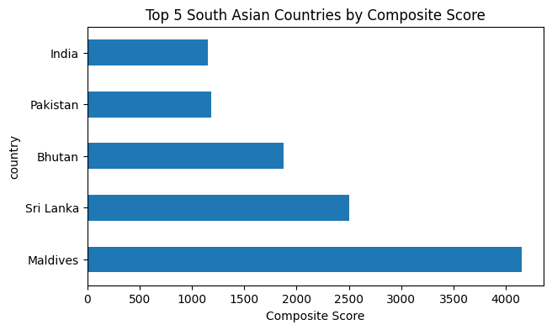
The chart highlights a sharp decline in composite scores among the top five South Asian countries, starting with the Maldives and ending with India. The most striking feature of the data is that the Maldives serves as a major outlier; its score is nearly double that of the runner-up, Sri Lanka, and roughly quadruple the scores of Pakistan and India. While the middle-ranked countries show a steady decrease, the bottom two are quite close in performance. Ultimately, the key takeaway is the vast inequality across the region; even among the top-performing nations, there is a massive gap between the frontrunner and the rest of the group.

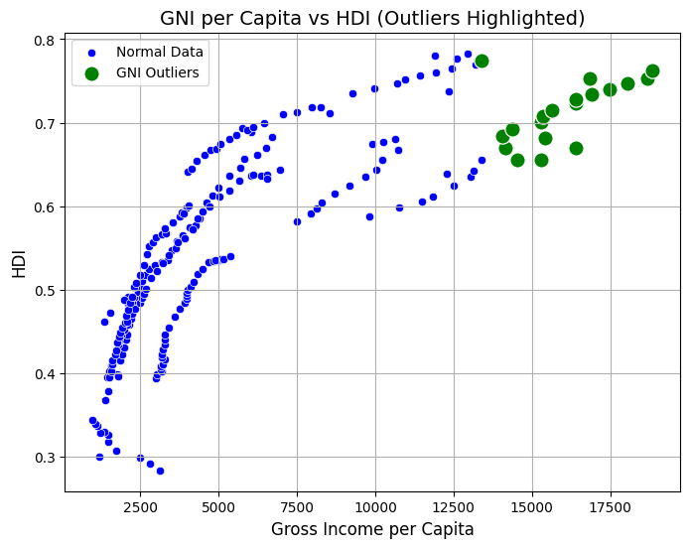
Afghanistan is typically an HDI outlier on the lower end.
Maldives or Sri Lanka may appear as high-GNI outliers.
Outliers occur due to: conflict (Afghanistan)
note there is no outliars found in hdi . since all the HDI values are between 0.284 and 0.783, which is within the fences (0.1805–0.9245).
small, tourism-based high-income economies (Maldives)
large population economies causing statistical spread
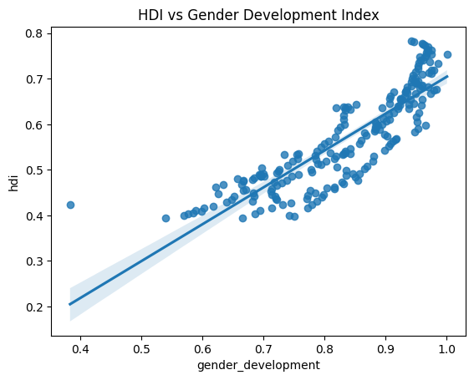
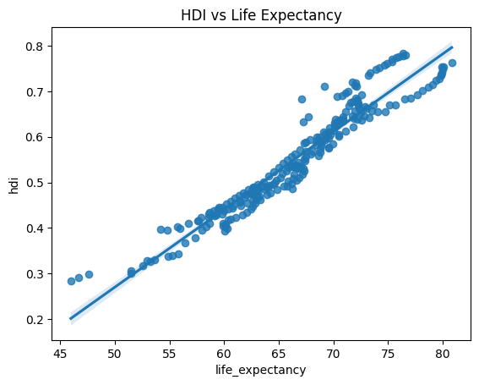
Life Expectancy usually has the strongest correlation with HDI.
Health improvements directly lift the HDI index.
Gender Development Index often has a positive but weaker correlation.
Gender equality is important, but its impasct is indirect compared to life expectancy.
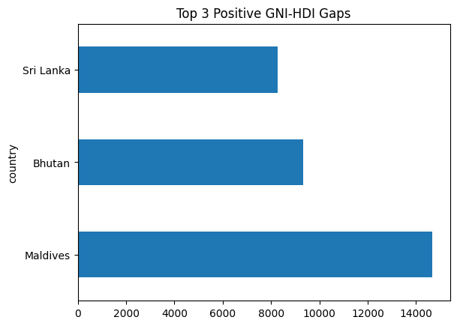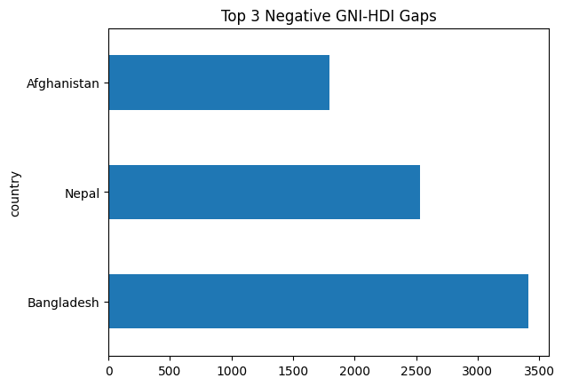

Large Positive Gap : GNI is high but HDI is lower than expected. Example causes:
income inequality
weak education systems
poor health services
Large Negative Gap : HDI is strong relative to income. Example causes:
strong social welfare
good education and healthcare despite lower income
effective government policies
In South Asia, Maldives/Sri Lanka often show negative gaps, and Pakistan/Afghanistan show positive gaps.

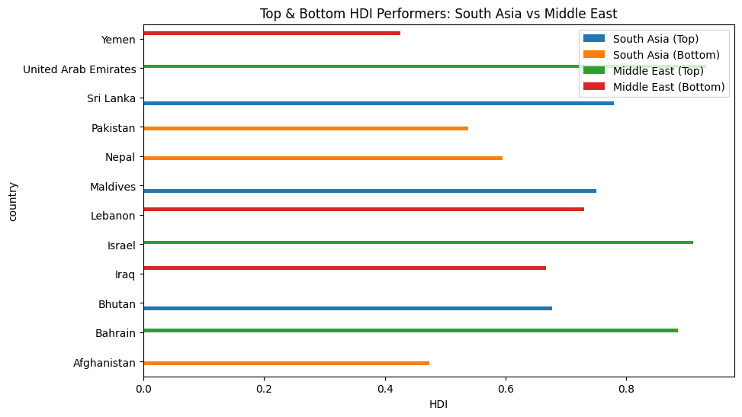
This chart compares human development across South Asia and the Middle East, showing that while the Middle East reaches much higher development peaks, it also experiences more extreme regional inequality. The top-performing Middle Eastern nations, such as the UAE and Israel, significantly outpace South Asia's leaders like Sri Lanka and the Maldives. However, the Middle East also contains the lowest overall performer—Yemen—which serves as a major outlier with a score even lower than the bottom-ranked South Asian countries. In contrast, while South Asia’s scores are generally lower, the gap between its highest and lowest performers is less drastic. Ultimately, the key takeaway is that the Middle East has achieved a much higher "ceiling" for human development, but progress across that region is far less consistent than in South Asia.
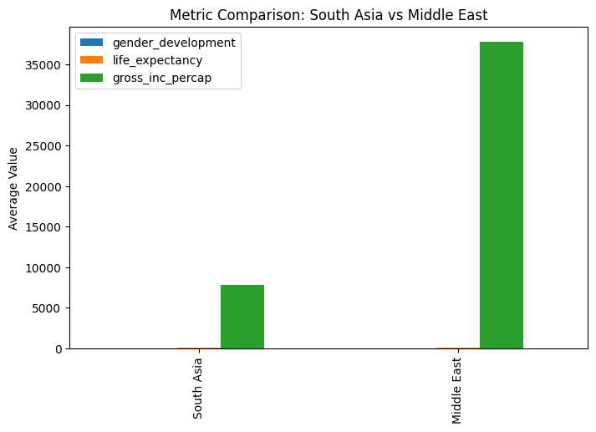
This chart compares average metrics between South Asia and the Middle East, highlighting a massive economic divide. The most dominant trend is the disparity in gross national income per capita, where the Middle East's average is nearly five times higher than South Asia’s. Because the income figures are so large, they create a major scale imbalance on the graph, making the bars for gender development and life expectancy look almost flat in comparison. Ultimately, the key takeaway is that the Middle East's significantly higher national wealth is the most striking difference between the two regions, overshadowing the other human development metrics shown here.

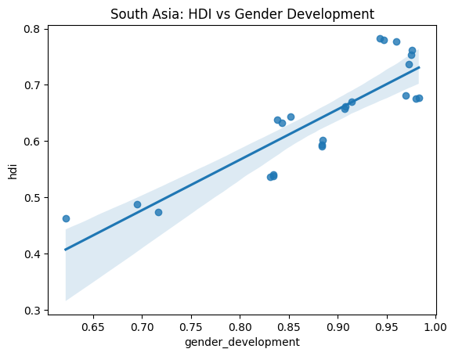
Looking at South Asia, it’s clear that a country’s overall human development is closely tied to how well it supports gender equality. The scatter plot shows a steady upward climb, where nations with higher gender development scores consistently reach much higher levels of general well-being. Most countries in the region are grouped toward the top right of the chart, showing that many are making progress in both areas simultaneously. Because the data points follow such a predictable path without any major outliers, it suggests that for this region, achieving high human development isn't really possible without also focusing on gender equity. Essentially, these two factors seem to move in lockstep, making gender progress a vital part of the region's overall success.
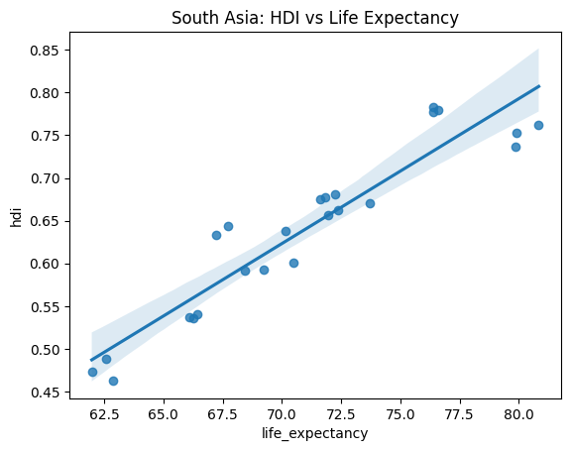
In South Asia, there is a very obvious connection between life expectancy and a country’s overall development level. The scatter plot reveals a strong upward trend, indicating that as people live longer, the Human Development Index (HDI) scores climb in a predictable way. Most countries in the region are grouped tightly along the trend line, showing that improved health outcomes are a major engine for broader progress. There aren't any massive outliers, meaning the relationship holds true across the board. The main takeaway is that for South Asian nations, raising the average lifespan is one of the most effective ways to drive up their total human development standing.
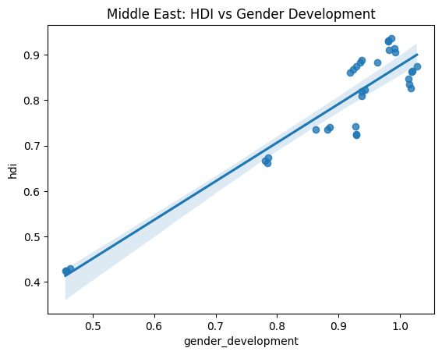
In the Middle East, there is a visible and powerful connection between gender equality and a country's general level of development. As shown in the chart, there is a clear upward path where improvements in gender-related metrics go hand-in-hand with higher overall human development scores. A large number of nations are grouped closely at the top end of the scale, showing that high levels of success in both areas often occur together. However, there is a noticeable gap between these leaders and a few countries at the very bottom of the chart that lag behind in both categories. Ultimately, this suggests that for countries in this region, prioritizing gender development is not just a social goal but a fundamental driver of wider human progress.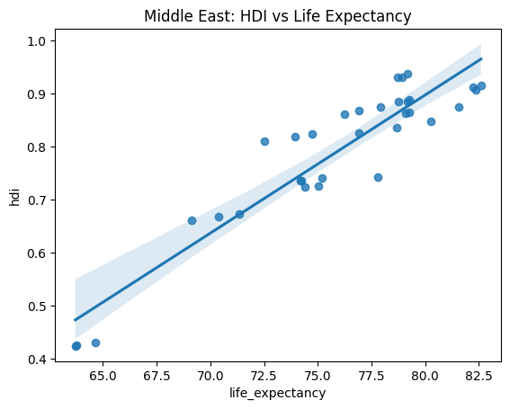
This chart reveals a strong and direct connection between life expectancy and human development across the Middle East. There is a clear positive trend showing that as people live longer, their country’s overall development score rises in a very predictable way. While a large number of nations are clustered at the high end of both scales, the data also highlights a significant gap between the region’s top performers and a few countries struggling with much lower health and development outcomes. Ultimately, the graph demonstrates that in the Middle East, a longer average lifespan is a fundamental building block for broader human progress.

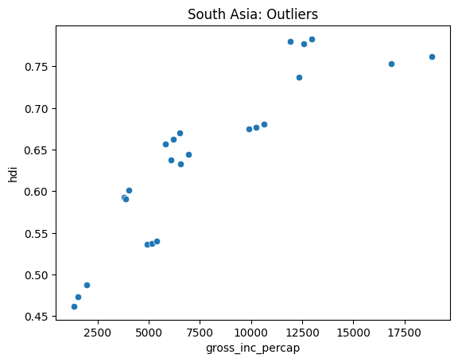
This scatter plot for South Asia shows a general positive correlation between national wealth and human development, where countries with higher gross income per capita typically achieve better HDI scores. Most nations in the region are clustered in the lower-to-mid income range, but the data becomes more spread out at higher income levels.
A key observation is the presence of outliers at the far right of the graph. Interestingly, the two wealthiest countries in the dataset do not hold the highest development scores; instead, a country with a significantly lower income level has reached the top of the HDI scale. This indicates that while increased wealth generally supports progress, it is not the only factor at play. The main takeaway is that some South Asian countries are more efficient at translating their economic resources into human development than their wealthier neighbors.
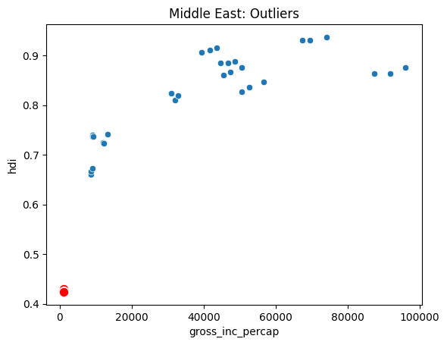
Overall, as gross income per capita increases, the Human Development Index (HDI) scores also tend to rise, following a clear upward curve.The most striking feature is the major outlier highlighted in red at the bottom-left corner, which represents a country struggling with both extremely low income and very low development levels compared to its neighbors. Additionally, at the top end of the scale, we see that the wealthiest countries aren't necessarily the leaders in development; several nations with more moderate incomes actually achieve higher HDI scores than the richest ones in the region.The big picture here is that while wealth is a major driver of progress in the Middle East, it isn't the only factor. The presence of a severe outlier highlights a massive development gap within the region, and the flattening trend at the high end suggests that extreme wealth alone doesn't always translate into better human outcomes.

5.2 Variation and Outliers
The Middle East displayed higher development consistency, while South Asia showed larger disparities. Outlier detection helped identify countries that deviated significantly from regional trends

6. Conclusion
This analysis demonstrates that HDI is influenced by multiple interconnected factors beyond income alone. While higher income generally corresponds to higher HDI, differences in health and education significantly affect development outcomes.
Regional comparisons reveal persistent inequalities, emphasizing the need for balanced development policies. The findings highlight the importance of using composite indicators like HDI to understand global development patterns.

